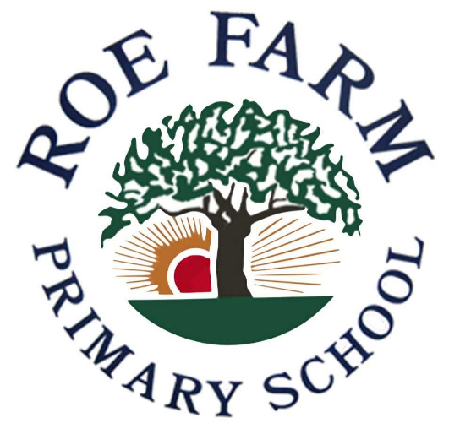
Reading Policy
Review Details
Reviewed by  Subject Co-ordinator: | N. Mardlin
Reviewed by  SLT: | H. Weston
Date of Last Review: | January 2023

Reading Policy – Roe Farm Primary School

At Roe Farm Primary School, we understand that reading is of vital importance to all children. It is paramount to us that all children are taught how to read and how to understand what they are reading. We promote a passion for reading throughout the school.
Passion for reading
We do this through sharing our love for reading with the children at any opportunity. Time is set aside each day to read high-quality and inspiring texts to the children for pleasure. As well as this, reading corners are set up in each classroom with good quality books available for children to read and enjoy. We promote the reading of a range of texts including fiction, non-fiction and poetry. At Christmas, teachers set up a Book Advent which involves children bringing in one of their favourite books wrapped up in Christmas paper. These are numbered and then each day leading up to Christmas a book is opened and the book is enjoyed. This was trialled Christmas 2022 and proved to be very successful.
Reading at Home
The children are encouraged to read at home and motivational competitions are in place to encourage this. Parents and carers are actively encouraged to listen to their children read and record comments in their reading diaries which are taken home each day and brought into school each day. If children lose or damage their reading book, they are charged £5 to replace it.
The lowest 20% of our readers
The lowest 20% of our readers are listened to by an adult in school each day of the school week. This is recorded in their diaries as well as in a folder for the teacher’s evidence. A stamp is placed in the child’s reading dairy informing others that they have listened to them read, as well as the date, title of book and pages read.
Author week
Once a term for a week at a time, each class spends a full week focusing on their class author (see appendix 1). During this week, inspirational texts are shared with the children and they complete a range of activities including comprehensions and craft activities as well as links to Geography and History. During the Spring term, teachers ensure that a non-fiction text is used during this week that is linked to the author’s book.
Whole class reading
Our reading lessons are delivered through the Whole Class Reading initiative. Teachers plan 3 lessons per week focusing on the following reading skills: predict, visualise, retrieve, question, vocabulary, summarise, clarify and sequence. Our texts link to our Talk 4 Writing Texts with the addition comparative texts (2 weeks on the focused text, the third week on the comparative text). Teachers plan using powerpoint or Smart Notebook ensuring they cover the range of skills. From year 3 onwards, the children cover at least two skills per lesson. All teachers have a Whole Class Reading display which shows these reading skills. Vocabulary activities are essential for the children to understand the text so new vocabulary is introduced early on in each unit and displayed on the class displays for children to keep referring to. Stickers are placed into the children’s books with the learning objectives on with space for the children to self-assess as well as the teacher to assess using a pink highlighter to indicate they found the activity difficult or don’t fully understand it, using an orange highlighter to indicate they needed a little help or partially understand it and finally green to show that they have a good understanding and have clearly met the learning objective.

Assessing readers
Children throughout the school complete a formal reading assessment each Summer term. Throughout the year, children are assessed in reading on a regular basis. Staff listen and assess children read twice a half-term, recording their assessments on grids provided which are broken down into year group reading levels with appropriate objectives as well as being broken down into working towards, at the expected standard or at greater depth. (see appendix 2) These grids are monitored by the Reading Lead and the Head teacher. The reading assessment records enable teachers to justify why they believe a child is reading at a certain level. Included in this assessment is a checklist of the relevant common exception words. This data is recorded on O’Track along with all the other data for other subjects.
Our Library
Our library is clearly organised with a great range of books that should be easy to locate. Children at Roe Farm are allowed to choose a library book and take this home. We record the books borrowed. Teachers take children to the library roughly once every fortnight to change their books. Over lunchtime during certain times of the year, children are allowed to spend time in the library as well as our book club being hosted there in the Summer Term.
Reading Buddies
A group of year 6 children are soon to be trained as reading buddies. This will mean they are reading role models and will assist in promoting the love of reading to others. Once a week they will listen to children read from year 3 and 4. This will be at a lunch time and will involve the children who rarely read at home so that they are given an opportunity to read with someone. Our reading buddies will wear prestigious badges on their jumpers so that everyone knows they are reading buddies.
Derby Book Festival Children’s Picture Book Award
Year 2 and 3 classes will be helping judge this exciting competition. Each class will gain a copy of the five shortlisted books and will explore and enjoy them, voting on their favourite. The overall winning author will either visit the classes in person or meet them virtually. Our reading lead will be shortlisting the books along with other primary teachers in Derby.
Engaging with our community
Our nursery children visit Chaddesden library along with their parents and carers during school time. We promote and encourage our children to participate in the annual Summer reading challenges.
World Book Day
This international event is celebrated heartily at Roe Farm Primary with all children and staff having the opportunity to come to school dressed as a book character. Different events happen throughout the day with the key focus being on celebrating the enjoyment of books. Teachers swap classes to read their favourite children’s book with their partner class. The staff act out a play of an inspirational children’s picture book to the school. Other activities are chosen and planned by the teachers individually to suit their classes.

